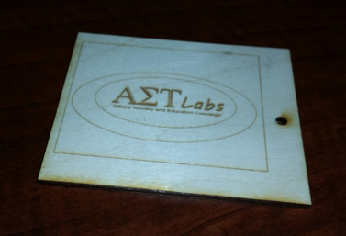
This simple cutting and engraving exercise demonstrates the fundamental principles of the laser. Speed, Power, Raster, Vector. Be sure to specify the correct properties for vector cuts.

Project Guidelines: Keep dimensions within a 4”x4” workspace. Be creative.
Learning Outcomes: To become familiar with the basics of CorelDraw and functionality of the laser.

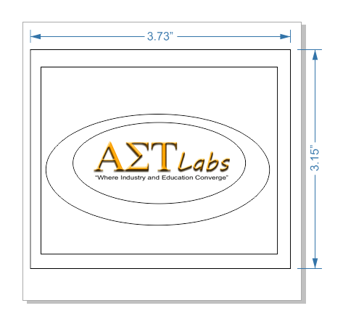
- Go to File, New, Create a New Document; Name new project and enter dimensions of workspace
- Navigate to your schools website. Use the Snipping Tool to capture your schools logo.
- Paste logo and scale as necessary.
- Use Text Tool to create content
- Use shape tools for creating 2 different borders
- Select All and Group Objects, align as necessary
- Select All and Ungroup Objects
- Select inside border and modify line point size to 1.0
- Select outermost border and modify line point size to Hairline
- Save project.

